GLSL using Freeglut & GLEW

Requirement :

* Windows OS
* OpenGL
* Codeblocks

Setting up MinGW

1. Create **library folder** for Freeglut and GLEW (ex: “D:\Library”)
2. Move freeglut and Glew folder into library folder

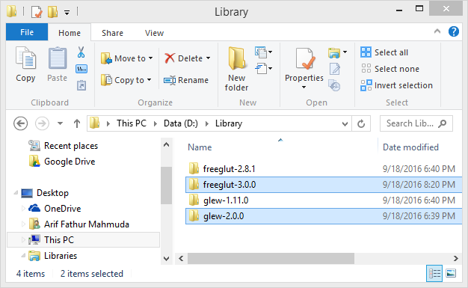

1. Place all **glews** **lib** folders contents into MinGW **lib** folder

(C:\Program Files (x86)\CodeBlocks\MinGW\lib)

1. Rename “**libfreeglut.a**” file found in freegluts lib folder(D:\Library\freeglut-3.0.0\lib) to “**freeglut.lib**” and copy it into MinGW **lib** folder.

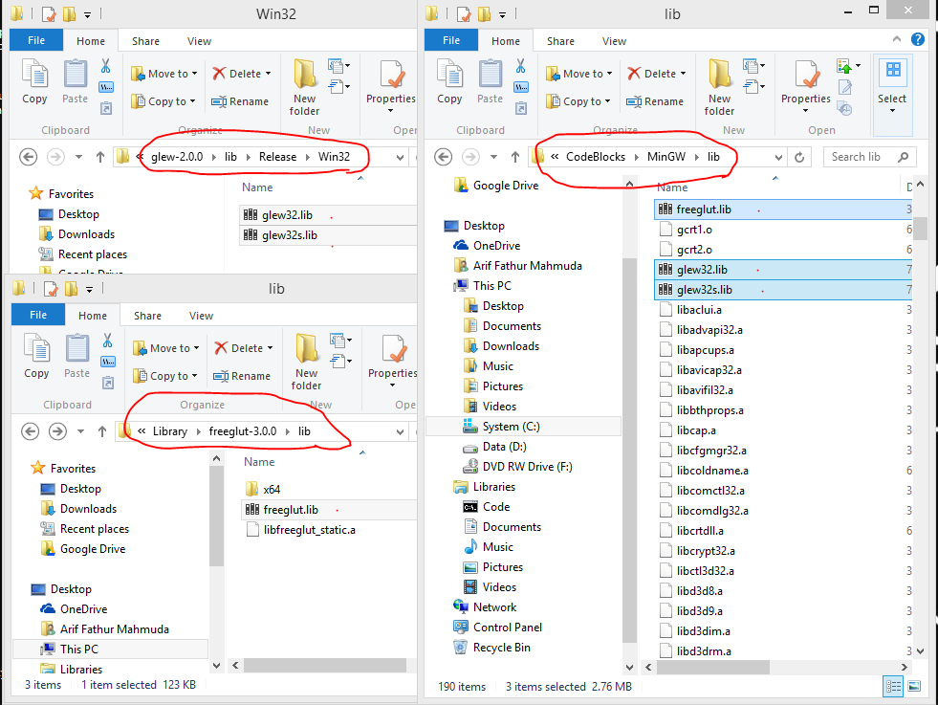

1. If your MinGW installation folder **doesn’t** have **GL.h** and **GLU.h** under MinGW **include/GL** folder please look for those headers in **microsoft SDK** include folder on your computer (C:\Program Files (x86)\Microsoft SDKs\Windows\v7.1A\Include\gl) and copy them into MinGW **include/GL** folder

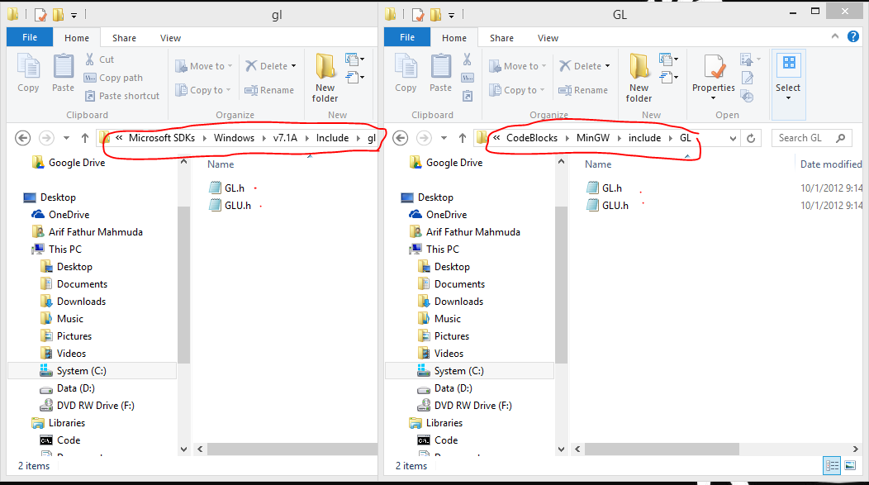

Setting up codeblocks (compiler)

1. Open Codeblocks and open **compiler option** (Setting->Compiler)
2. Under “**Search Directories->Compiler**” tab, add **freeglut** and **GLEW** **include** folders.

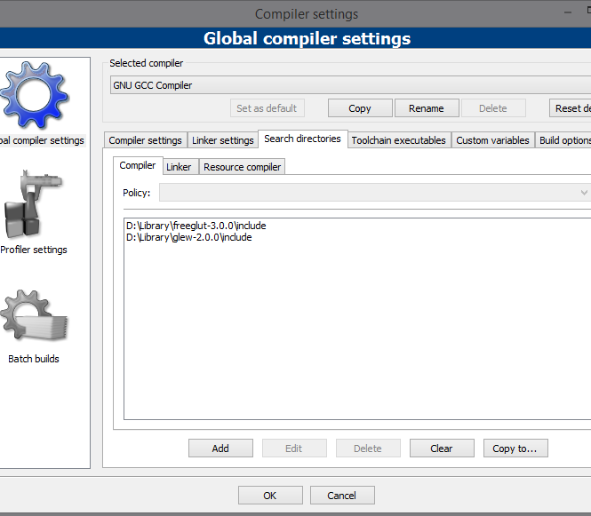

Setting up project (new project and linker)

1. Create **new** project in examples folder
2. **Add** files inside **common** and **include** folder into project.
3. Add **example1.cpp.** (labs-examples\CHAPTER02_CODE\LINUX_VERSIONS)

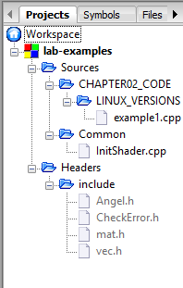

1. As we already have GL headers in MinGW, we could **delete** **GL** **folder** inside include in example.
2. Open **Build options**(Right click on project -> properties -> project’s build options)
3. In Search directories -> Compiler tab, add example **include** folder. (labs-examples\include)

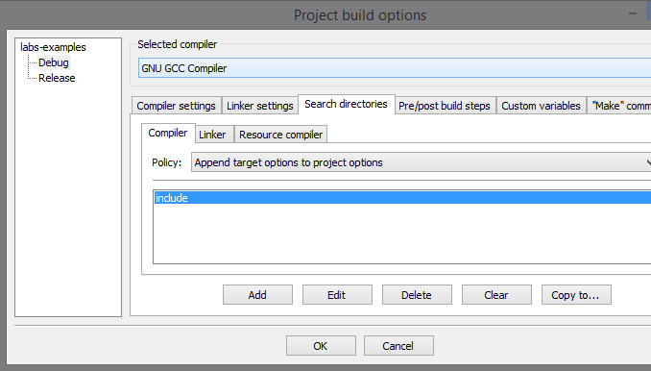

1. Open **project’s build options**( Right click on project -> properties -> project’s build options )
2. In compiler settings -> #defines tab, add “**GLEW_STATIC**” (w/o quotes)

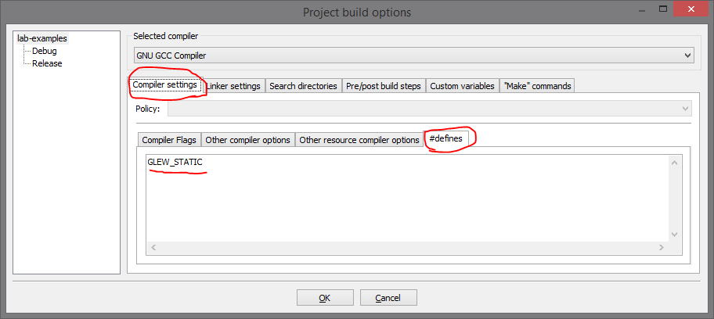

1. In linker settings tab , add **libraries** like so (order matters)

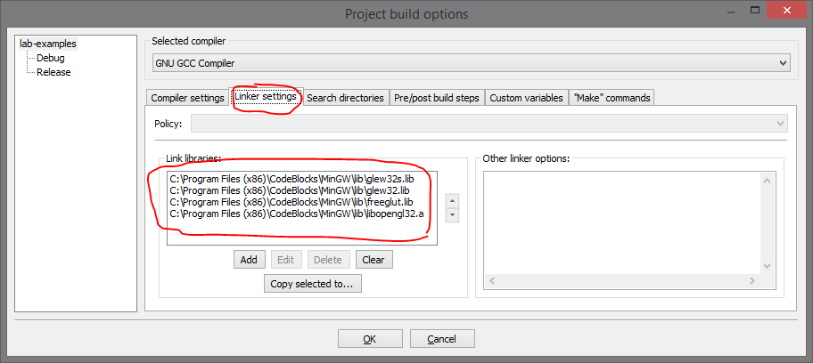

1. In Search directories -> Compiler tab, add MinGW **include** folder.

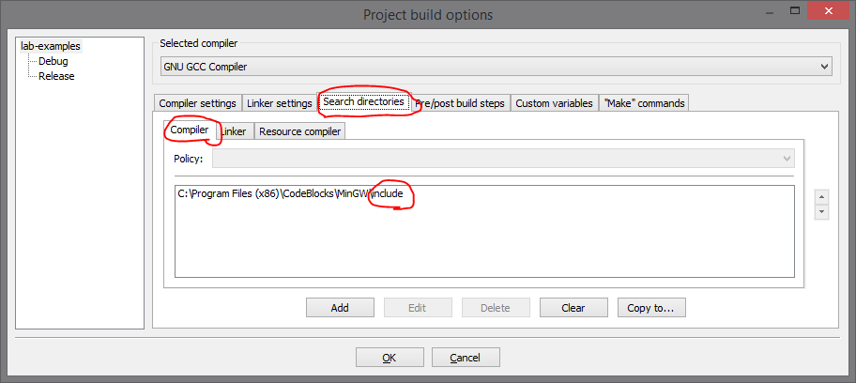

1. In Search directories -> Linker tab, add MinGW **lib** folder.

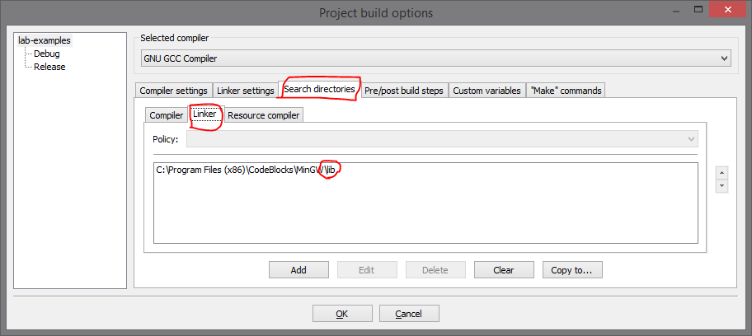

1. Load project in Codeblocks.
2. Hit “**Build**” (do not run).
3. Place **freeglut.dll** and **glew32.dll** and all **shaders** (ex : fshader21.glsl, vshader21.glsl) into **debug** (or release) folder found in your project folder.

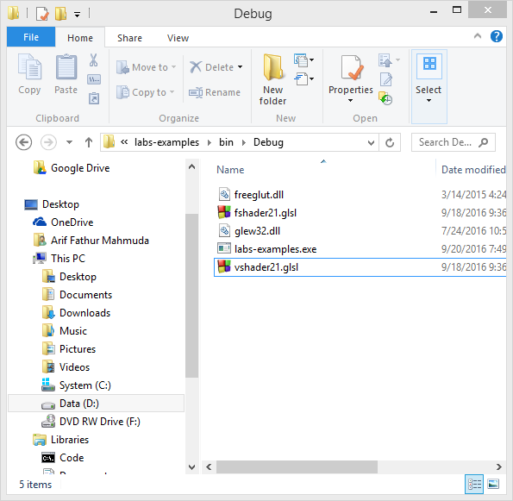

1. Run executable from windows explorer or cmd.

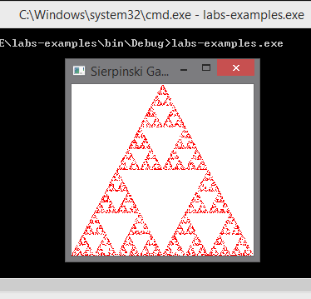

Tips :

* For Step 1, you can place and name library folder wherever and whatever you like.
* For step 8 and 12-16, you can simple copy another project and change the files(source codes and headers)

Faq :

1. Can I place freeglut.dll and glew32.dll in C:\Windows\System32 folder instead?
2. Yes you can, this way you don’t need to place them in debug (or release) folder, but other who doesn’t have those file cannot run your executable (.exe).
3. Can I place all freeglut and glew headers (include contents) into MinGW include/gl folder instead?
4. Yes you can, this way you can skip step 7. But it’s easier to maintain a separate library folder (ex : test different freeglut or glew version or uninstall freeglut or glew).
5. I set libsrary correctly, still got error
6. There are three different setting window that looks the same.
   1. Compiler setting
   2. Build options
   3. Projet’ build options
7. I got “**undefined reference to `_imp__glut\*\*\***” or “**undefined reference to `_imp__glew\*\*\***”errors
8. Make sure to do step 4,14, and 15 correctly
9. Use 32 bit version of freeglut.lib (not the one in x64 folder)
10. I got “**unresolved external symbol __imp____glut\*\*\*** **_ATEXIT_HACK\*\*\***” errors
11. Try define the following line before including glew.h (in file : angel2.h)  
    #define GLUT_DISABLE_ATEXIT_HACK

* Can I use gl.h and glu.h from other pc?
  + Not guaranteed
* Creating new project
  + Create new empty project in labs-examples folder
* Example1.cpp -> Grafkom\labs-examples\CHAPTER02_CODE\LINUX_VERSIONS
* New project-> empty project -> next -> place inside labs-example folder-> next-> finish
* Angle.h not defined
  + Project -> build options -> search direc… -> compiler-> add include folder that contains angle.h